Welcome to the Lego® Club!

Hi! My name is Dr. Brittany and I run the Lego® Club.

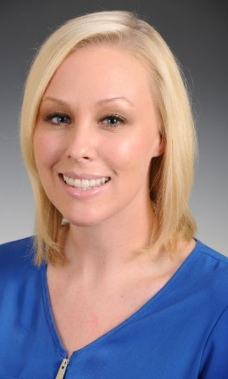

The Lego® Club is so much fun! It’s a place where kids who love Legos® can be creative, make movies, and meet other kids who love Legos® too!

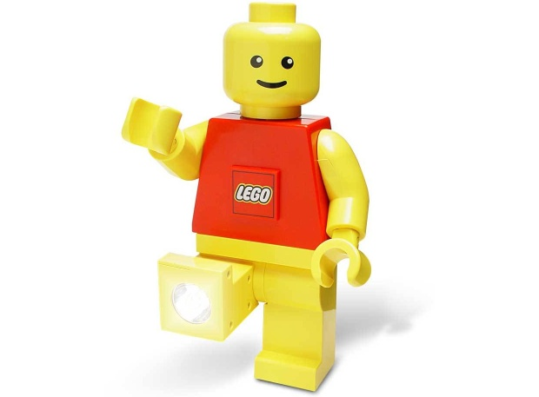

In the Lego® Club we will build sets, make creations using our imagination, and develop scripts to make stop animation movies.

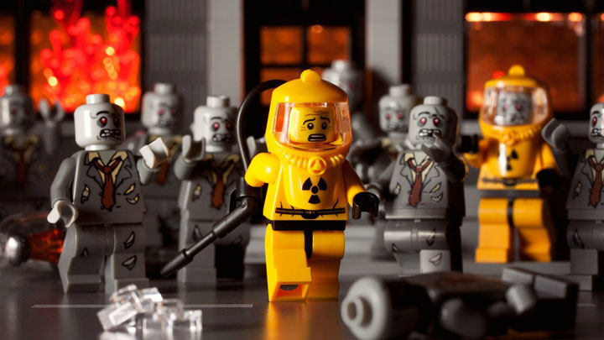

You will work with Dr. Brittany and the other group members to complete these activities. We will work as a team!

The group will be once a week for one hour in Doylestown, PA. Your parent(s) will wait in the waiting area while the Lego® Club meets in another room.
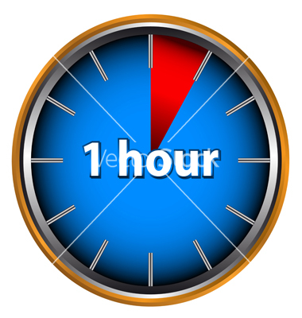

The Lego® Club is a safe place free of name calling and bullying. The Lego® Club’s main rules are to try your best, use your words when frustrated, and most importantly HAVE FUN!

If you are having a tough day or are frustrated during Lego® Club, you can ask Dr. Brittany for help or a break. Dr. Brittany is here to help you have fun and make new friends!

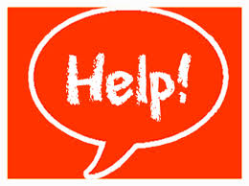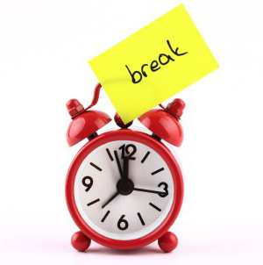

Welcome to the Lego® club! We can’t wait to meet you!

